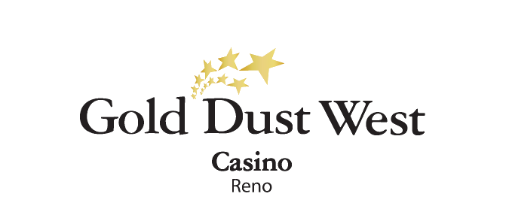
Strike It Rich
Saturday Drawings
March-April 2025
Rules and Regulations

- The promotion is open to every member of the Gold Rewards club.
- The promotion starts on Saturday, March 1st and ends on Saturday, April 26th at Gold Dust West Reno (9 Saturdays).
- The promotion runs every Saturday from 5:00pm to 8:00pm.
- Members earn 1 drawing ticket for every 100 points accumulated.

- Starting at 3:00pm each Saturday, members can use the Promotional Kiosk Machine to activate their tickets. By swiping their card, selecting "Strike It Rich" under promotions, and confirming with "yes," tickets will be entered into the virtual drawing drum.

- From 5:00pm onwards, three contestants will be randomly selected from the virtual drawing drum every 15 minutes.

- Each contestant will choose one of the 12 Treasure Chests, taking turns until the treasure is found.
- The contestant who discovers the treasure will proceed to the next round of the game.
- The other two contestants will each receive $75 in E-CASH.

- A game board will be set up, and the winner will select a card from the top level.
- Each card will reveal either a cash prize or the word "DIG."
- If a cash prize is revealed, the game ends, and the winner takes home that amount.
- If a "DIG" card is revealed, the winner continues to dig, selecting another card from the next level, which features higher cash prizes.
- If the winner successfully digs through all levels and finds the treasure, they will win $750 in CASH.

- Premium Club Members who WIN the game will receive additional E-CASH bonuses: $75 for Ultimate Gold, $50 for Black Gold, and $25 for White Gold.

- Members can win twice each Saturday at any time throughout the promotion period.
- All prizes are taxable in this promotion and contribute to the $600 threshold for a 1099.
- Winners must have their Social Security number on file to collect any prize.
- E-CASH prizes will be available for 6 days from the date and time they are credited to the member's account.
- The drawing drum will be emptied after each week's promotion.

- Rules & Regulations are subject to change.
- In the event of technical difficulties with the drawing system, a specific procedure will be followed. Initially, a marketing employee will retrieve a report of all activated entries and select a Hot Seat winner. If this procedure cannot be implemented, all winners will be selected through the hot seat system.
- Participation in this promotion grants the Gold Dust West permission to utilize any photos taken for Marketing purposes.
- Management reserves all rights to change, alter or cancel this promotion at any time, with or without notice.

