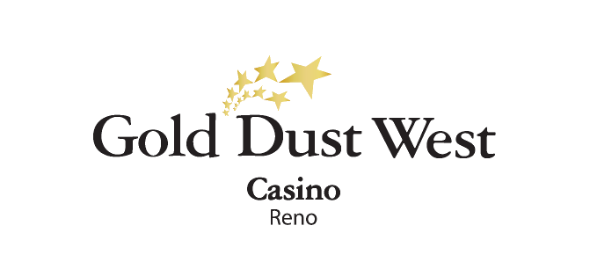
Twos-Day
Drawings
Rules and Regulations

- Promotion open to all members of the Gold Rewards Club.
- The promotion will take place on Tuesdays in January and February at Gold Dust West Reno, from 3:00pm to 6:00pm.
- Members will receive 1 drawing ticket for every 25 points earned starting each Monday at 3:00am.

- Every Tuesday, from 2:00pm onwards, members can access the Promotional Kiosk Machine to activate their tickets into the virtual draw module. By swiping their card, selecting “Twos-Day” under promotions, and confirming "yes," tickets will be sent into the virtual drawing drum.

- Starting at 3:00pm, and for every 30 minutes from 3:00pm to 6:00pm, 2 contestants are selected by the virtual drawing drum.

- Each contestant will receive one dice to roll, and they will take turns rolling.
- The first contestant to arrive at the Promotional Area will roll the dice first.
- The first contestant to roll a number 2, will win and receive $222 in E-CASH.
- The other contestant receives $22 in E-CASH and $22 in Comps.

- There are a total of 14 winners every Tuesday.
- Members can win twice each Tuesday at any time throughout the promotion period.
- E-CASH prizes will be available for 6 days from the date and time they are credited to the member's account.
- The drawing drum will be emptied at the end of each week's promotion.
- Rules & Regulations are subject to change.
- All prizes are taxable in this promotion and contribute to the $600 threshold for a 1099. Winners must have their Social Security number on file to collect any prize.

- In the event of technical difficulties with the drawing system, a specific procedure will be followed. Initially, a marketing employee will retrieve a report of all activated entries and select a Hot Seat winner. If this procedure cannot be implemented, all winners will be selected through the hot seat system.

- Participation in this promotion grants Gold Dust West permission to utilize any photos taken for marketing purposes.
- Management reserves all rights to change, alter, or cancel this promotion at any time, with or without notice.

