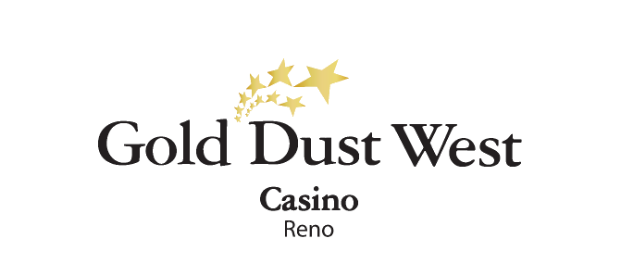
Holiday Hunt
Kiosk Game
Wednesday, December 25th, 2024
Rules and Regulations

- Promotion happening on Wednesday, December 25th, 2024, from 3:00am to 11:59m at Gold Dust West Reno.
- All members of the Gold Rewards club will have the opportunity to engage in a 2-level Kiosk Game, featuring exciting prizes in E-CASH, Gift Cards & Comps.

Participation Guidelines:
- Members must swipe their card at any Promotional Kiosk Machine to participate.
- Each member is entitled to play a maximum of 2 times if they earned the required points.
- The game has 2 levels, which can be accessed based on the following base point thresholds:
- 1st level: Upon accumulating 150 base points.
- 2nd level: Upon accumulating 300 base points.

- Base points must be earned exclusively at Gold Dust West Reno, starting at 3:00 am.
- Members are guaranteed a prize for each level they play in the Kiosk Game, with rewards ranging from $5 to $25 in E-CASH, Gift Cards, or Comps.
- E-CASH and Comp prizes are automatically credited to players' accounts upon winning.
- Gift Card prizes will generate a ticket that can be redeemed at Guest Services.
- The prize structure is based on an estimated 280 Kiosk Game participations throughout the day.

- Guests must have their Social Security number on file to claim any prize.
- Guests are responsible for all applicable taxes.
- Rules & Regulations are subject to change.
- Participation in this promotion grants Gold Dust West Reno permission to utilize any photos taken for Marketing purposes.
- Management reserves all rights to change, alter, or cancel this promotion at any time, with or without notice.

