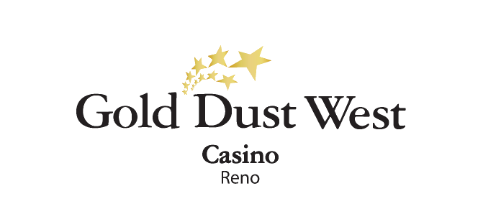
Holidayland
November-December 2024
Rules and Regulations

- The promotion is open to every member of the Gold Rewards club.
- The promotion starts on Saturday, November 2nd and ends on Saturday, December 28th at Gold Dust West Reno (9 Saturdays).
- The promotion runs every Saturday from 4:00pm to 9:00pm.
  - Players earn 1 drawing ticket for every 100 points accumulated.

- Starting at 2:00pm each Saturday, players can use the Promotional Kiosk Machine to activate their tickets. By swiping their card, selecting "Holidayland" under promotions, and confirming with "yes," tickets will be entered into the virtual drawing drum.

- From 4:00pm onwards, two contestants will be randomly selected from the virtual drawing module every 20 minutes.
- These contestants will play the game, rolling dice multiple times. The first to land on the GRAND PRIZE spot will win and receive $250 in cash.
- The other contestant will receive $50 in E-CASH or Gift Cards shown on their final spot.
- At 9:00pm, there will be a final drawing where the winner will receive $1,000 CASH prize.

- Bottom winners can be selected only once per hour and will be eligible again at the start of the next hour.
- CASH winners can only win once between 4:00pm and 8:40pm, but all participants can enter the 9:00pm drawing.

- Premium Club Members who WIN the game will receive additional E-CASH bonuses: $75 for Ultimate Gold, $50 for Black Gold, and $25 for White Gold.

- All prizes are taxable in this promotion and contribute to the $600 threshold for a 1099. Winners must have their Social Security number on file to collect any prize.
- The drawing drum will be emptied after each week's promotion.

- In the event of technical difficulties with the drawing system, a specific procedure will be followed. Initially, a marketing employee will retrieve a report of all activated entries and select a Hot Seat winner. If this procedure cannot be implemented, all winners will be selected through the hot seat system.
- Rules & Regulations are subject to change.
- Participation in this promotion grants the Gold Dust West permission to utilize any photos taken for Marketing purposes.
- Management reserves all rights to change, alter or cancel this promotion at any time, with or without notice.

