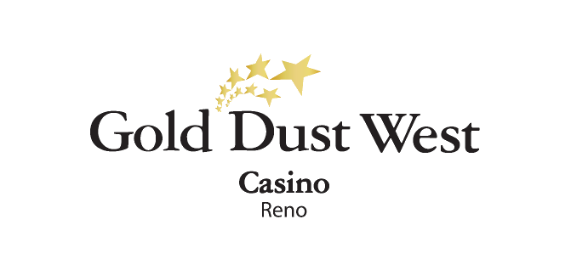

**Fright Night Frenzy**

Slot Tournament

**Thursday, October 31st, 2024**

Rules and Regulations

* Event happening on Thursday, October 31st, 2024, at Gold Dust West Reno.
* Event open to every member of the Gold Rewards Club.
* **Tournament begins at 5:00pm and ends at 8:00pm.**
* Members have to earn 150 base points during the day to play the 1st tournament session.
* Members who earn 300 base points during the day can play a 2nd tournament session.
* **Session scores will be combined.** Playing twice increases the chances of making it into the TOP 10.
* There are only 24 sessions available, offering 144 spots available.
* Sessions will be held every 5 minutes or when session is full.
* 5 players are required to start a session.
* **Session winners will receive $31 in E-CASH.**
* Guests will play 2 minute sessions.
* 2 entries maximum per participant.
* **TOP 10 Winners with the highest scores will be awarded at 8:30pm at the tournament area.**
* Winners must be present to receive their prize. Prize will go to the next winner if original winner is not present.
* In case of a tie, the award will be split evenly.

**Prizes:**

1st Place $1000 Cash

2nd Place $750 Cash

3rd Place $500 Cash

4th Place $300 E-CASH

5th Place $250 E-CASH

6th Place $200 E-CASH

7th Place $200 E-CASH

8th Place $150 E-CASH

9th Place $150 E-CASH

10th Place $100 E-CASH

* **At 8:15pm, before announcing the slot tournament winners, marketing will select 3 participants with the best Halloween costumes, who will each receive E-CASH prizes.**
* In order to be called as a Halloween costume winner, participants must have taken part in the slot tournament.
* Costumes must be suitable for a public setting. Attire that is offensive, excessively revealing, or portrays violence, illegal activities, or explicit content is strictly forbidden. Costumes should not include real or realistic weapons, sharp objects, masks, or anything that could pose a safety risk. Additionally, costumes must not obstruct vision or movement in a manner that could cause accidents.
* Participants can win in both the slot tournament and the Halloween costume contest.

**Prizes:**

1st Place $250 E-CASH

2nd Place $150 E-CASH

3rd Place $100 E-CASH

* Winners Social Security number will need to be on file to collect any prize.
* Participation in this promotion grants the Gold Dust West permission to utilize any photos taken for Marketing purposes.
* Management reserves all rights to change, alter or cancel this promotion at any time, with or without notice.